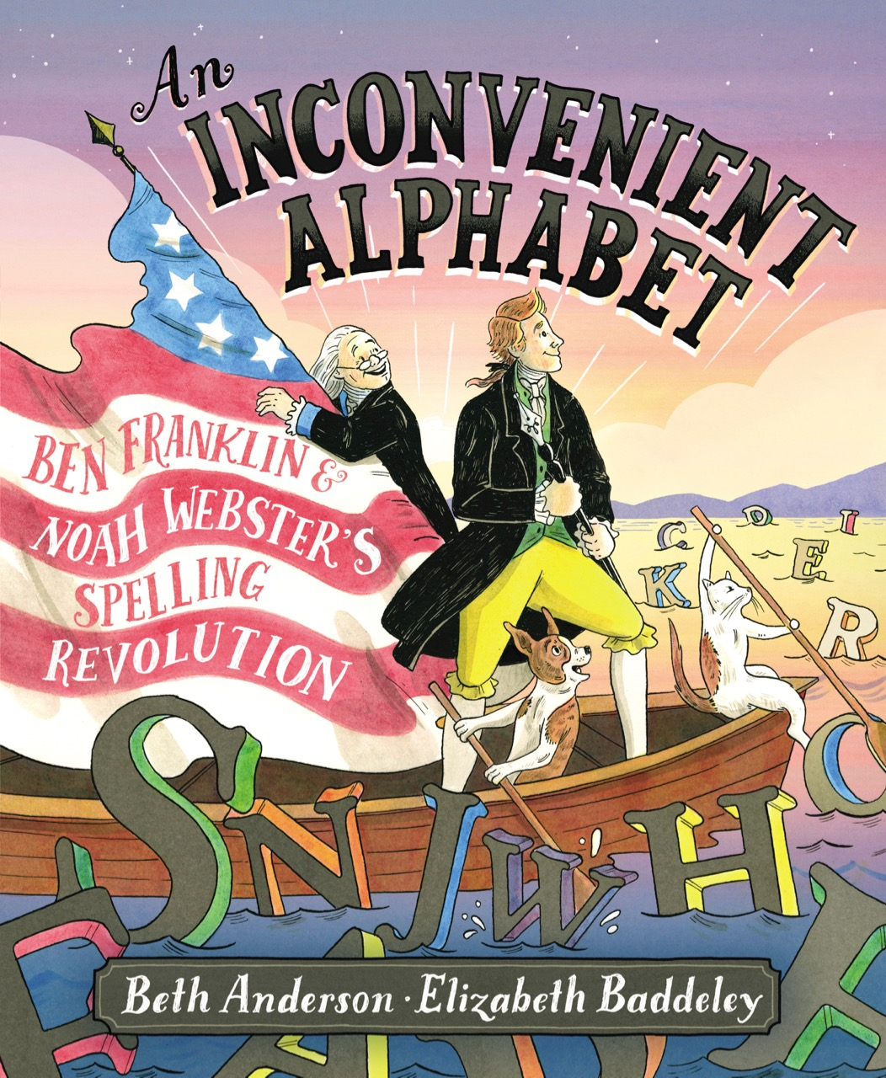
Activities for

AN INCONVENIENT ALPHABET, BEN FRANKLIN AND NOAH WEBSTER’S SPELLING REVOLUTION

An Educator’s Guide is available from Simon & Schuster HERE. (link
available at release date)

Here are some additional activities to use in conjunction with the book. Pages in bold are included
in this packet.

CRAFTS
- Use alphabet beads to create bracelets, pins, bookmarks, etc.
- Get a feel for how Ben Franklin used print blocks by using rubber stamp letters to write a message.
- Use the instructions and pattern to make a tricorn hat.

SPELLING GAMES
- Use letter dice to create words and your own games.
- Bananagrams® is great for spelling practice and making crosswords. It’s available in several
versions: the original letter tiles in uppercase letters, a version with larger letter tiles, and My First Bananagrams® which uses lower case letters and letter combos for some vowel sounds and
digraphs such as SH. (Ben and Noah would LOVE that one!)
- Scrabble®

ACTIVITY PAGES
- Crossword puzzle and answer key
- Word Search puzzle and answer key

WORD WORK
- Homophones: Generate a list of pairs of homophones. (ex. hare/hair) Create a sentence using
each pair.
- Charades: Use your list of homophones and cut into slips of paper. Let 2 kids draw one slip and
each act out one word of the pair simultaneously while others guess the words.

CHARACTERS
- Use quotations to better understand Ben and Noah. Listen to the Characters
- Complete character maps for Ben and Noah.
- Use a Venn diagram to compare Ben and Noah.
- Which character is more like you? Why?

PROVERBS
- Ben Franklin is famous for his proverbs. Use this proverbs to explore connections to self
and the story. Explore Proverbs

Tricorn Hat
- Trace pattern 3 times on construction paper. Cut out.
- Decorate by drawing braided trim if you want.
- Add a feather in the middle of one side. Attach with a large sticker.
- Staple the ends to form a triangle.
- Adjust size as needed.

[pattern and instructions from ehow.com]

AN INCONVENIENT ALPHABET
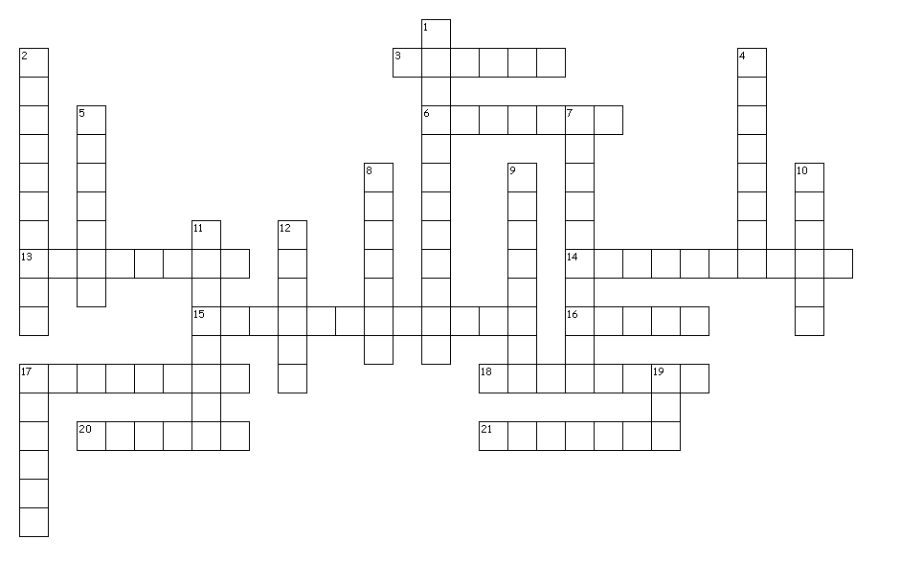
Down
1. city where Noah met Ben
2. finally, Noah created this
4. the 26 letters
5. Noah's last name
7. a war or when people want a big
change
8. one of Ben's jobs that uses a press
9. one of Noah's jobs that's in a school
10. things we hear
11. what Ben, Noah, and the people ran
out of
12. When everyone knows about you,
you're ____ .
17. making no sound
19. Ben's letter for the SH sound

Across
3. Noah took a ______.
6. symbols we use to write
13. a word that describes something in
the U.S.
14. to know what something means
15. bothersome, troublesome
16. things we think of
17. putting letters in order to make a
word
18. Ben's last name
20. someone who puts words on paper
21. language you are using right now

Created by Puzzlemaker at DiscoveryEducation.com

AN INCONVENIENT ALPHABET
Crossword Puzzle Answer Key

Across
3. Noah took a ______. chance
6. symbols we use to write letters
13. a word that describes something in the U.S. American
14. to know what something means understand
15. bothersome, troublesome inconvenient
16. things we think of ideas
17. putting letters in order to make a word spelling
18. Ben's last name Franklin
20. someone who puts words on paper writer
21. language you are using right now English

Down
1. city where Noah met Ben Philadelphia
2. finally, Noah created this dictionary
4. the 26 letters alphabet
5. Noah's last name Webster
7. a war or when people want a big change revolution
8. one of Ben's jobs that uses a press printer
9. one of Noah's jobs that's in a school educator
10. things we hear sounds
11. what Ben, Noah, and the people ran out of patience
12. When everyone knows about you, you're ____ . famous
17. making no sound silent
19. Ben's letter for the SH sound ish

AN INCONVENIENT ALPHABET
Listen to the Characters

Here are some quotations from Ben Franklin and Noah Webster.

What can you understand about their personalities from their words?
How do their words connect to the story?

BEN FRANKLIN:
- Energy and persistence conquer all things.
- Without continual growth and progress, such words as improvement, achievement, and
success have no meaning.
- When you’re finished changing, you’re finished.
- Do not fear mistakes. You will know failure. Continue to reach out.
- You may delay, but time will not.
- I have never entered into any controversy in defense of my opinions; I leave them to
take their chance in the world. ..

Here are a few quotes from his interaction with Noah and their spelling revolution…
- The true question then is…whether the conveniences will not on the whole, be greater
than the inconveniences.
- We might perfectly get over it in a week’s time…
- The present bad spelling is only bad because contrary to the present bad rules.

NOAH WEBSTER:
- …they (people who mispronounce words) offend the ear and embarrass the language…
- The revolution of America is yet incomplete…
- General Washington has expressed the warmest wishes for the success of my undertakings.
- …crush all opposition…
- Sometime or other it must be done.
- Now is the time, and this the country…
- …a column in each newspaper, printed in the new spelling, would in six months, familiarize…
show advantages…remove objections…
- …it would assist foreigners and our own children…
- It would, in that case, be as difficult to spell wrong, as it is now to spell right.
- Our language is indeed pronounced very differently than the spelling; this is an
inconvenience we regret, but cannot remedy.

See Bibliography of AN INCONVENIENT ALPHABET for sources.

AN INCONVENIENT ALPHABET
Explore Proverbs

Benjamin Franklin is famous for his proverbs, wise and witty sayings about life. Below are some
famous proverbs. Not all of them are Franklin’s. Discuss the meanings of each and how they
apply to the story. Then consider how they might apply to your own life.

Choose one that you think connects to the story or your life. Write about the connection using
textual evidence or examples from your own experience.

Easier said than done.
It’s hard to teach an old dog new tricks.
Old habits die hard.
Time is money.
A penny saved is a penny earned.
There is no rule without its exception.
The old forget, the young don’t know.
The first step is always the hardest.
Leave well enough alone.
No pain, no gain.
After all is said and done, more is said than done.
The remedy is often worse than the disease.
Nothing ventured, nothing gained.
The spirit is willing, but the flesh is weak.
Two heads are better than one.
You can lead a horse to water, but you can’t make him drink.

