“A Chain of Inspiration” by Beth Anderson
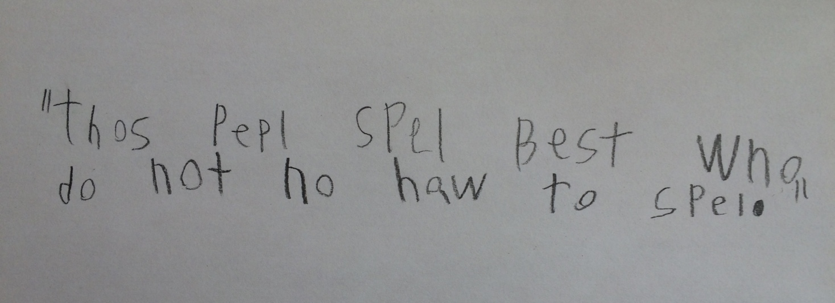

A picture book requires a very long chain of inspiration. What inspires you to write in the first place? What inspires you to write that particular story? What inspires you to persevere through the revisions and rejections?
I’ve always enjoyed writing, but had never pursued it professionally. It was my English as a Second Language students who inspired me to finally take on my “someday” of writing for children—to research the industry, to join writing critique groups, to take classes, to keep at it until I found my niche.
And it was my students who led me to that niche—historical fiction and nonfiction. The kind of books that evoked a “Wow!” or “Is that really true?” and urged them to think, question, and do further investigation, opening their minds to new ideas, to history, or science.
So, when I saw a newsfeed blurb stating that Ben Franklin invented a new alphabet… “Wow! Who knew?” For someone who loves language, that’s intriguing!
Then I learned that Franklin wanted us to spell phonetically… For someone who taught English, that would have been a dream come true!
And then I read the quote from Franklin you see in the picture (clearly written by one of those people who spell best!)… For someone who nurtured kids from letters and sounds to “invented spelling” and on to accepted-yet-crazy English spelling, that went straight to my heart! I dug in. The more research I did, the more fascinating it became.
In Ben Franklin’s day, people spelled words however they wanted. He was frustrated with trying to decipher everyone’s writing and felt people should write the sounds they heard. Ah…but the English alphabet was a mess with multiple sounds for letters and multiple letter combinations for sounds. So, the great inventor created a new alphabet. But despite all his successes, this idea didn’t fly. Too inconvenient. Done. Failure. The end. Well, that doesn’t make a great story, does it? But this tidbit was just too interesting to let go…so I kept digging, spurred on by Ben’s inspiring words.
Along came Noah Webster. “Wow! They knew each other!” Suffice it to say that further digging inspired more digging. I persevered, inspired by the notion that when kids use “invented spelling” they are doing egzaklee wut Ben and Noah wontid. Wow! I was hooked. Full speed ahead!
So, the chain of inspiration kept growing, from people and books, with encouragement and experimentation, through revision after revision, until finally it was a story. A story that I hope will inspire kids’ interest in history and the courage to let their ideas “take their chance in the world,” just like Ben and Noah.
Wishing “wow” moments for one and all!

